**Engineers for Exploration**

Dillon Hicks

**Setting up Waypoints from CSV in Litchi**

# Prerequisites:

QGIS 3.0.1

Litchi

Excel or OpenOffice Calc

# Setup:

The machine that this documentation ran on was a Windows 10 computer, with no additional software included for GIS and OpenOffice

The iPad used to run Litchi had iOS version 11.3 and Litchi version 2.14

# 

# 

# 

# 

# 

# 

# Documentation:

This is a follow up from the previous tutorial with the prerequisite of already having a CSV formed from the area of interest in the previous steps

# 

Once you have your CSV file it should look like this either in Excel or OpenOffice Calc

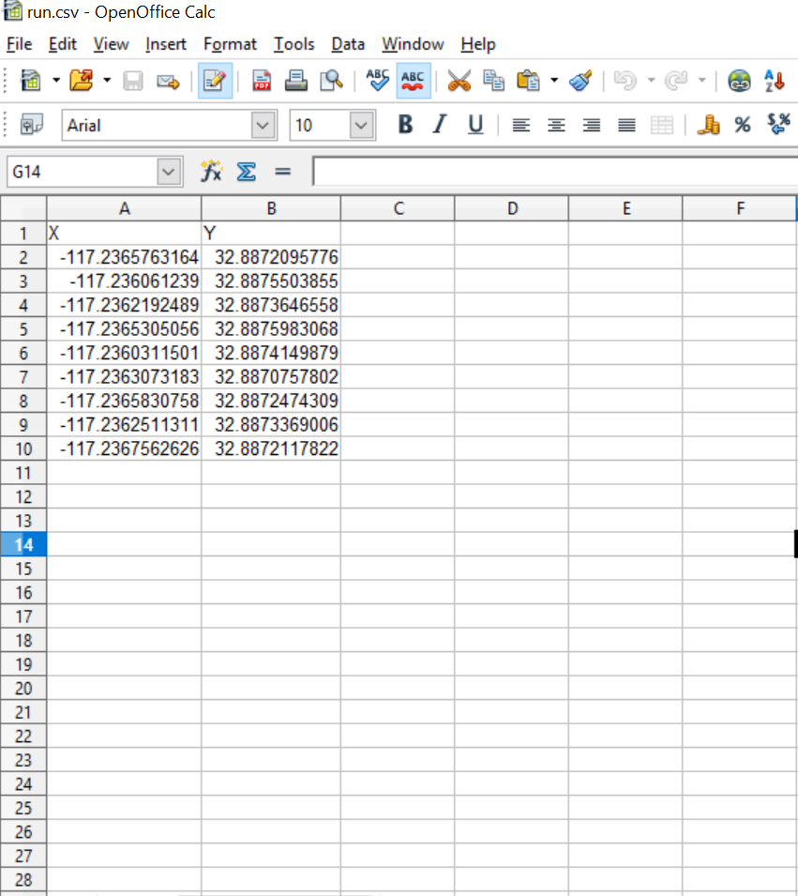

Now, since Litchi is fairly particular with how it takes the input CSV and QGIS can’t output in a format that is instantly readable from Litchi. Delete the first row of the CSV and switch the first and second row of the CSV and save the file.

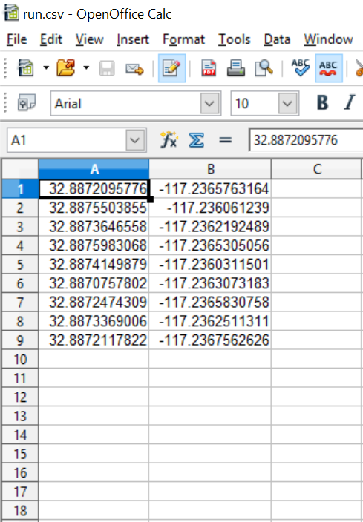

Go to the litchi mission hub at <https://flylitchi.com/hub> and log into your litchi account.

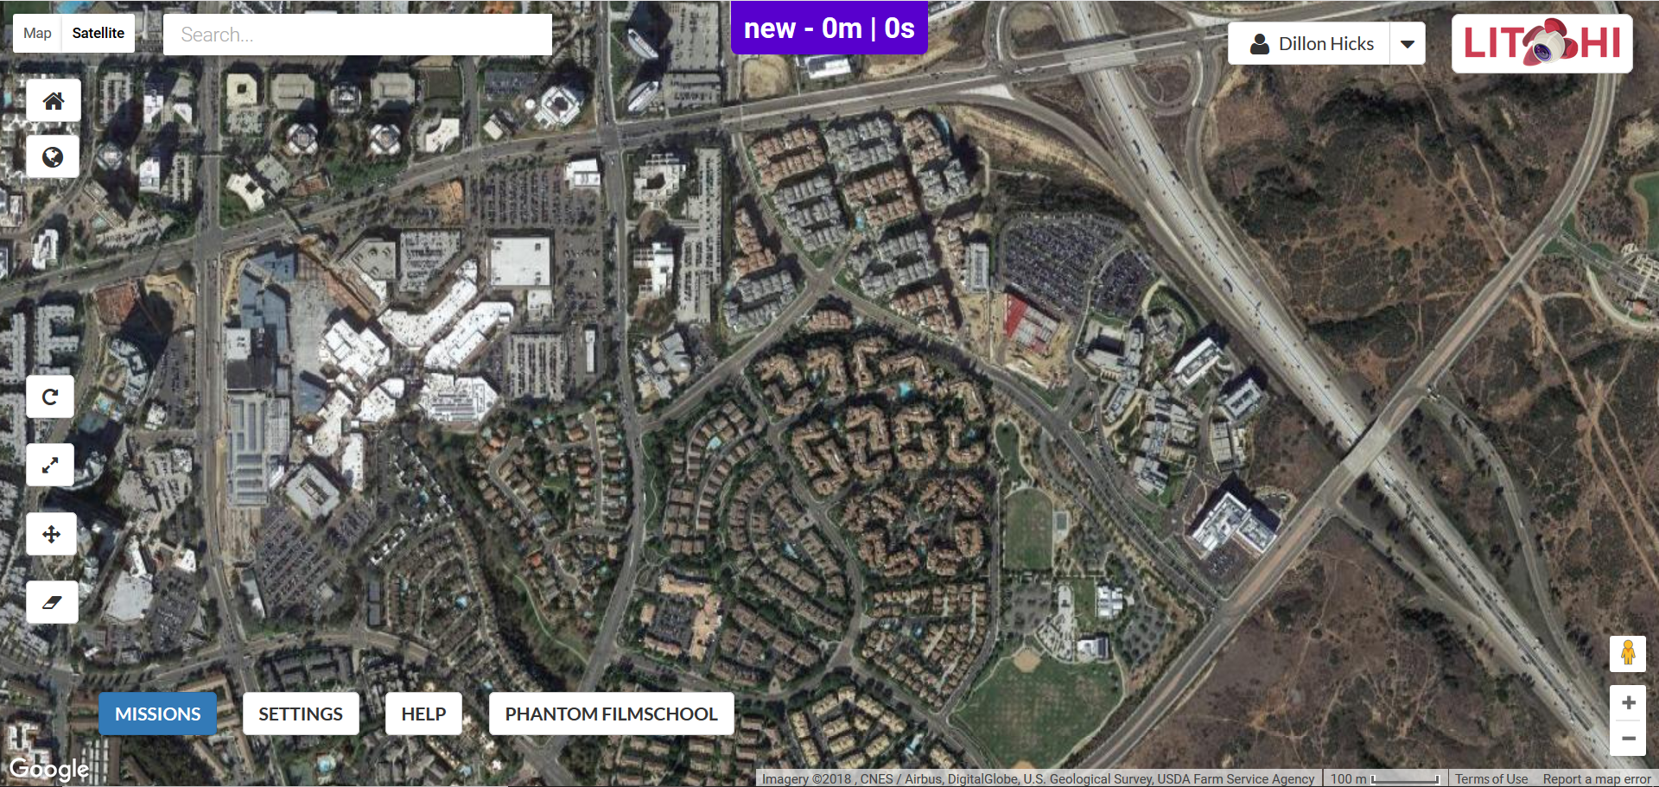

Load the CSV file that you just edited by going to Missions > Load and browsing for the CSV

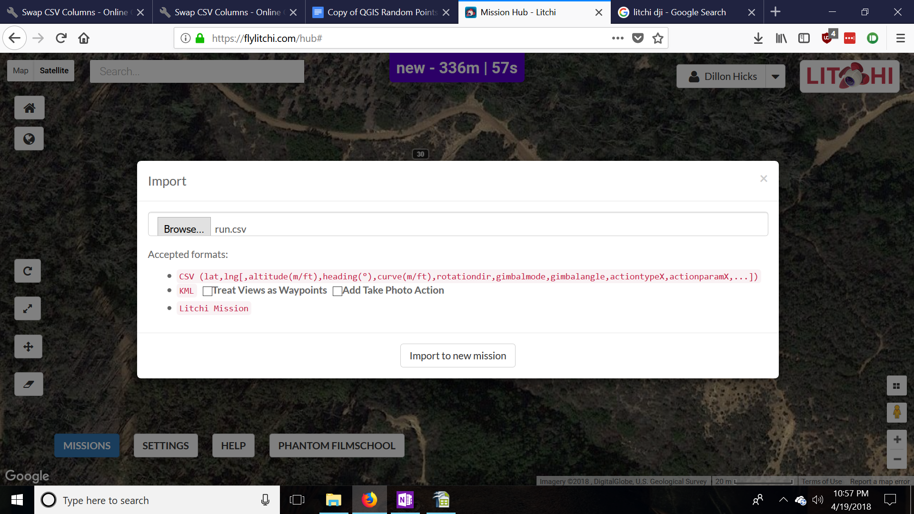

Now you can edit the waypoints in your browser and add actions to the random waypoints, in this case taking photos. Click save 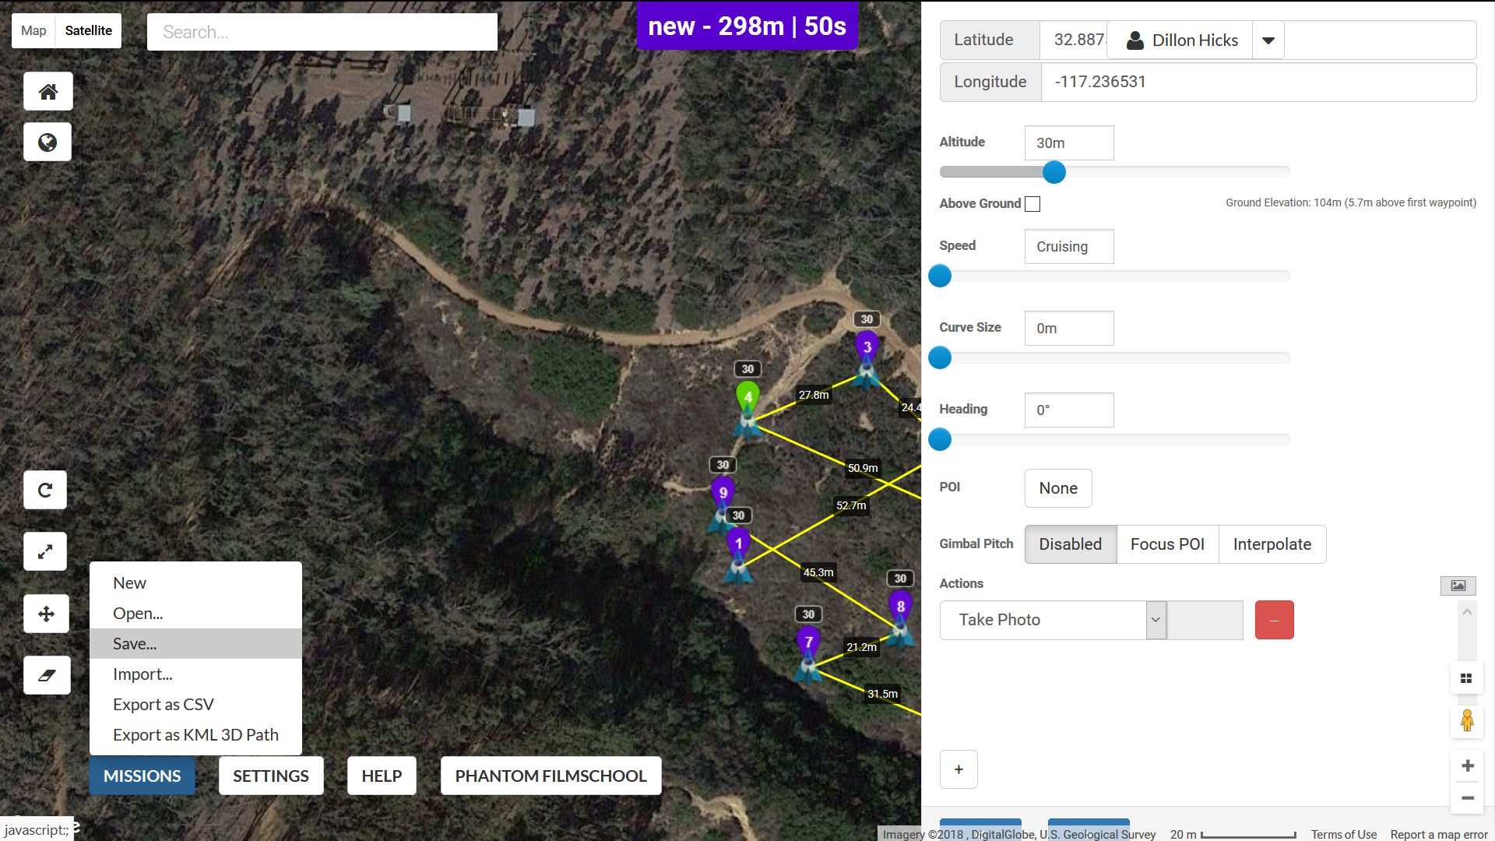

Save the name of this mission 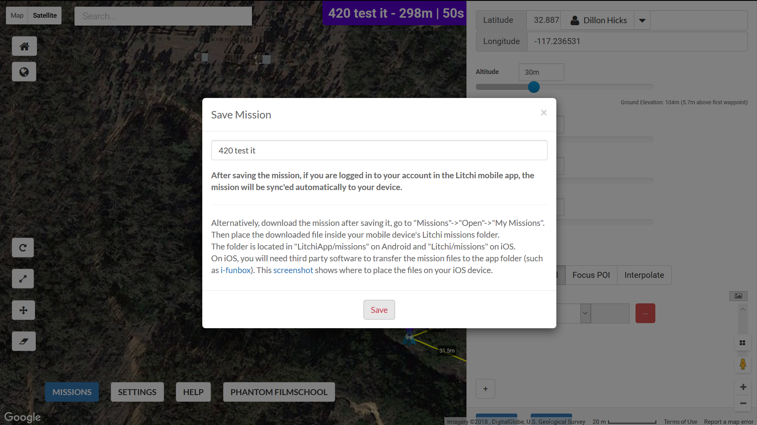

After you save it, it should also save to your account and then you can load it off of your iPad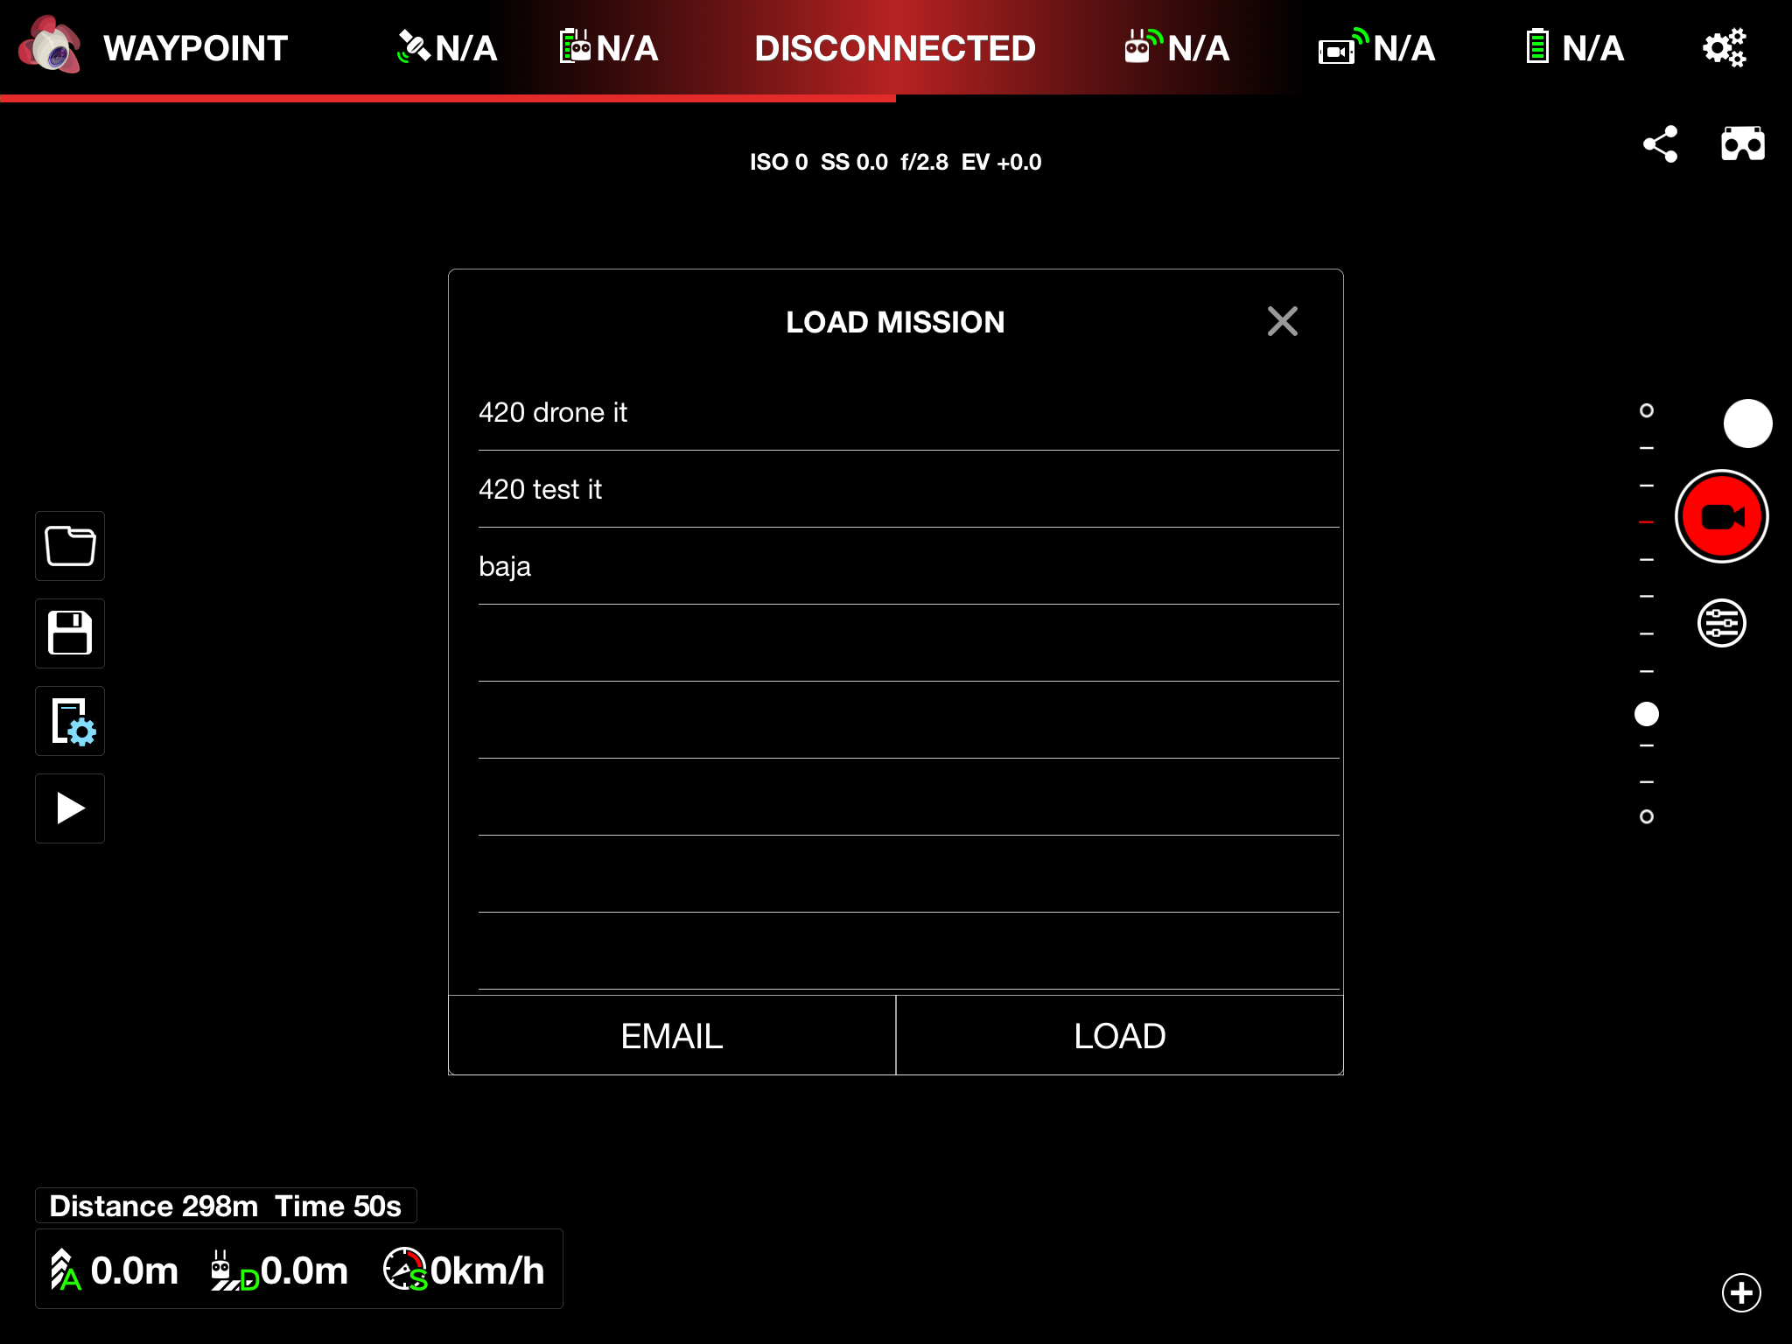

You can now view it and start the mission from your iPad.

